HOUSING IN THE US vs. HOUSING IN THE LÄNDLE
Housing in the US has been strongly influenced by the American way of life.
The typical features of the American way of life in connection with housing are:
- mobility
- access to cheap energy
- enough space
- young history
Let us first of all have a closer look at MOBILITY.
In the vast country of the USA, mobility has always been very important.
Originally, Native Americans moved across the USA on horses.

The horses also carried the houses of American Indians: the tepees.
It was important that these tepees could be transported very easily, because the Indians did not live at the same place for a very long time.
They were constantly moving around across the American Plains.

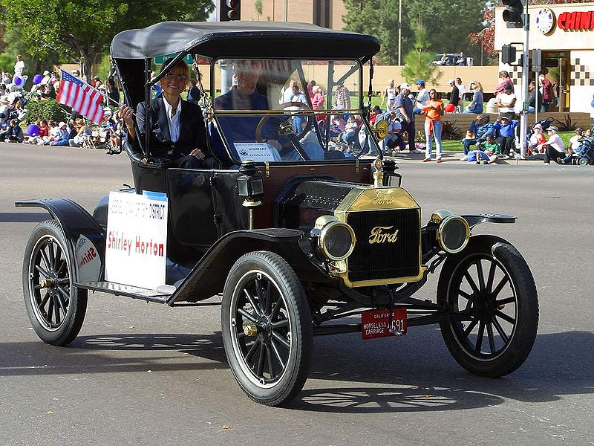 | When the first cars were produced, people in America were able to move around more comfortably.  In this picture we can see a FORD Model T, also known as Tin Lizzie.  The Tin Lizzie is generally regarded as the first affordable automobile, the car that opened travel to the common middle-class American;  The Model T was the first automobile that was mass-produced on moving assembly lines.
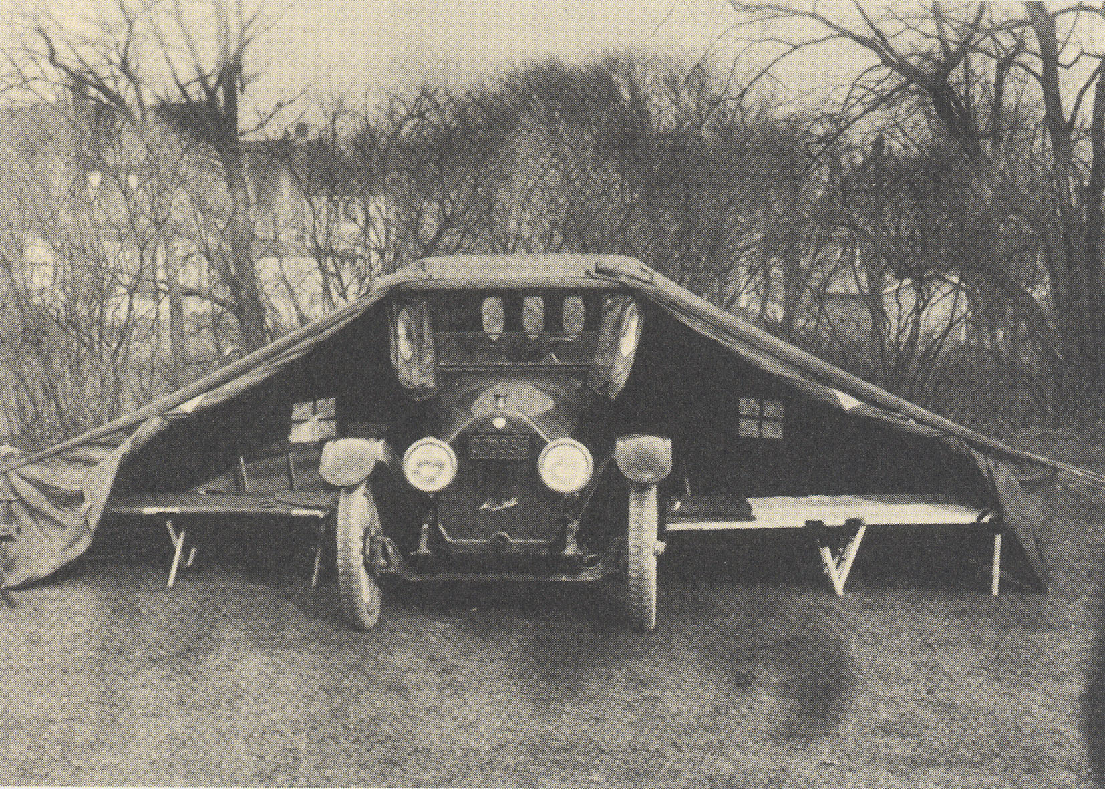 | Here we can see that cars can also be transformed into houses.
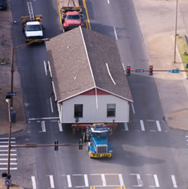 | Nowadays, not just people are mobile in their cars in the US . Houses are mobile, too.  As you can see here, whole houses can be transported from one place to another on a truck.

Let us now have a closer look at what effects access to CHEAP ENERGY has on housing in the US:
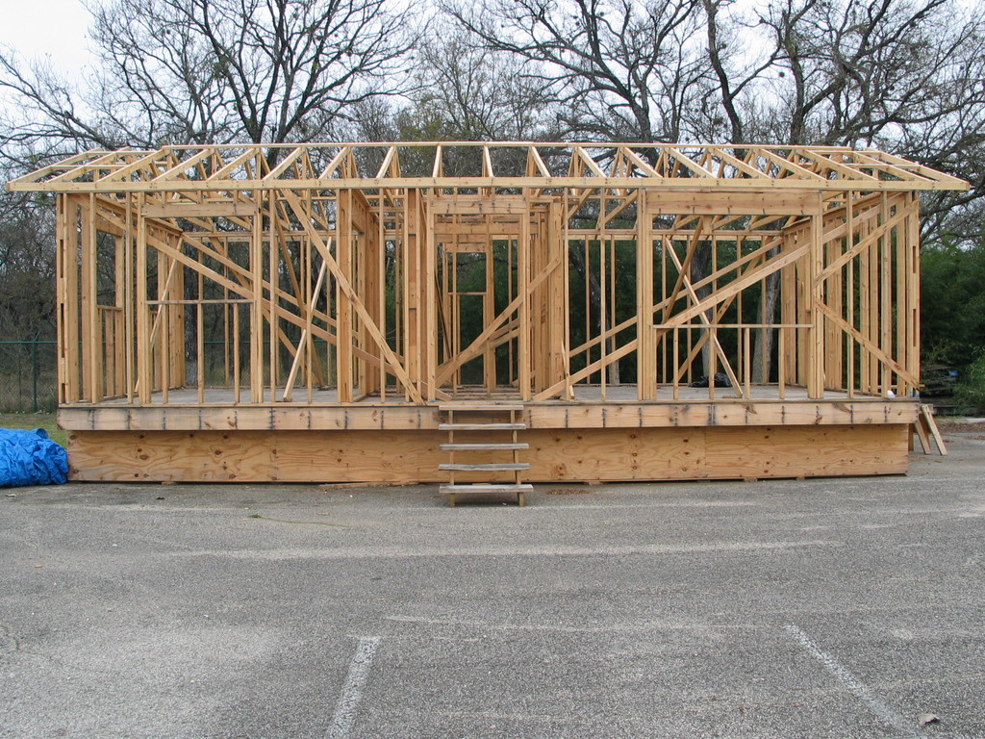  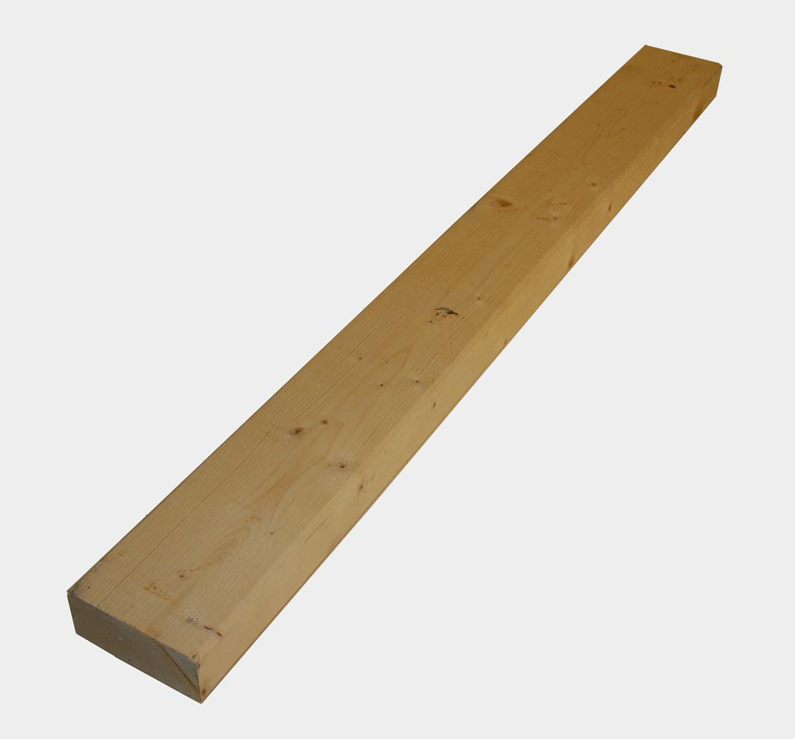 | In this picture you can see the skeleton construction of a typical American house.  In the US, oil prices are still quite low (in comparison to Europe).  As a result, the houses in the US do not tend to be insulated as much as our houses in Austria - although winters can get very cold in the US.  In addition to a lack of insulation, houses in the US usually have quite thin walls, too.  They are just as thick as the wooden beam you can see in this picture.
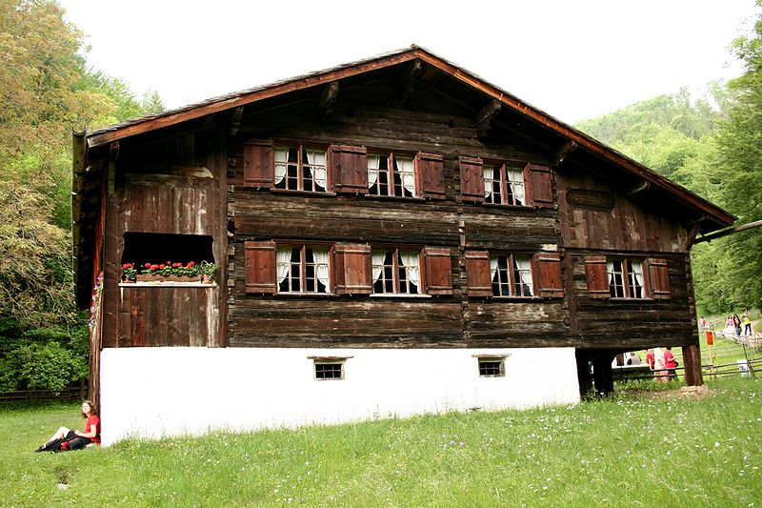 | In Austria, oil prices are a lot higher than in the US.  Therefore, our traditional houses normally have thick walls.

Another important factor affecting housing in the US is that there is ENOUGH SPACE in the US.
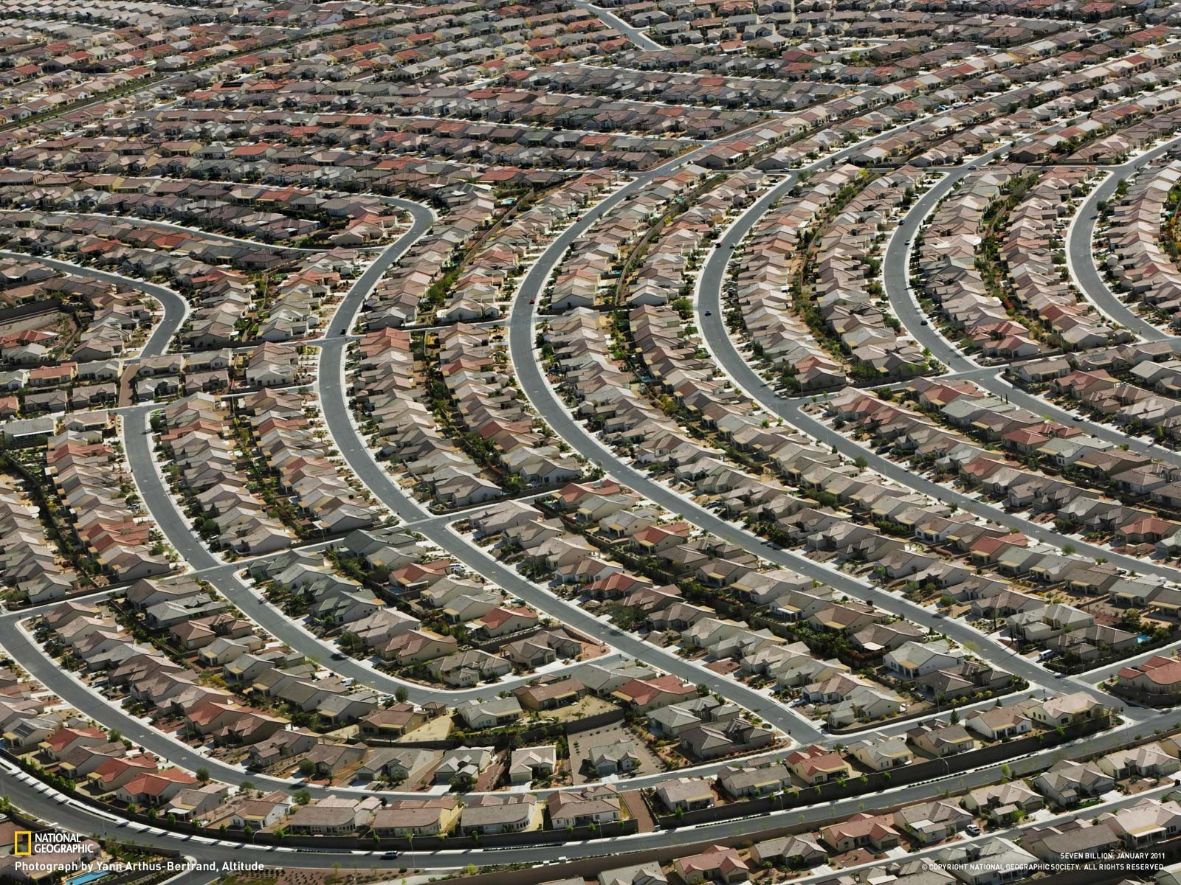 | As there is plenty of space in the US, building plots outside of big cities are cheaper than in Austria.  This picture shows how people live in suburbs outside big cities in the US.  Each family has its own house and its own garden, which is called a “yard“.
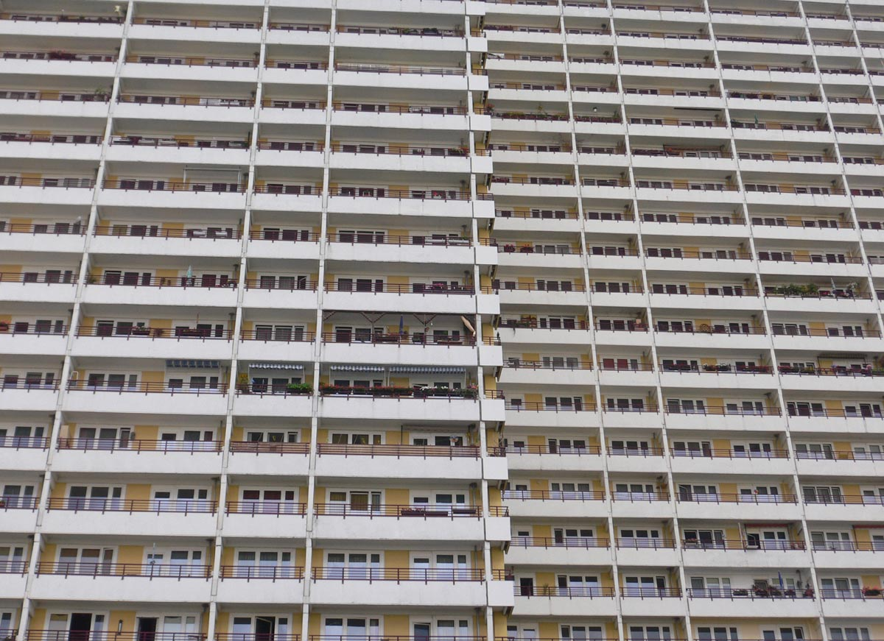 | In Austria, on the other hand, there is not enough space and building plots are expensive.  Many families who do not want to pay so much money to buy expensive plots and build a house on them buy or rent a flat (in US English: “apartment”) in a block of flats.

The USA has a very YOUNG HISTORY and this of course also affects housing.
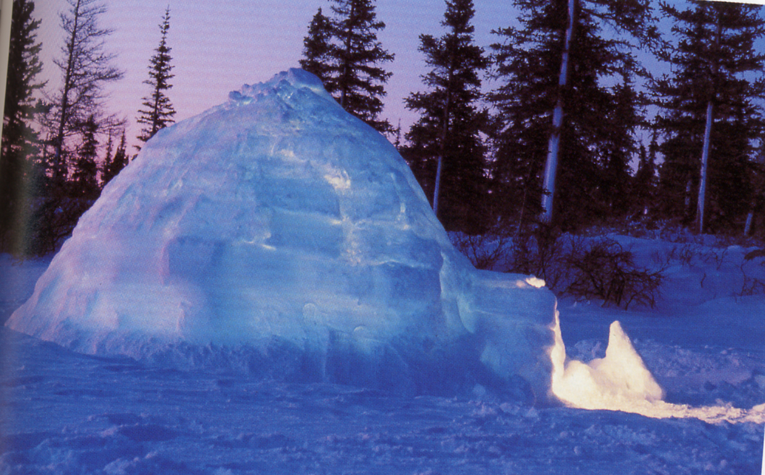 | The following pictures show the traditional historic houses of Native Americans:  an igloo, like those lived in by the Inuit.
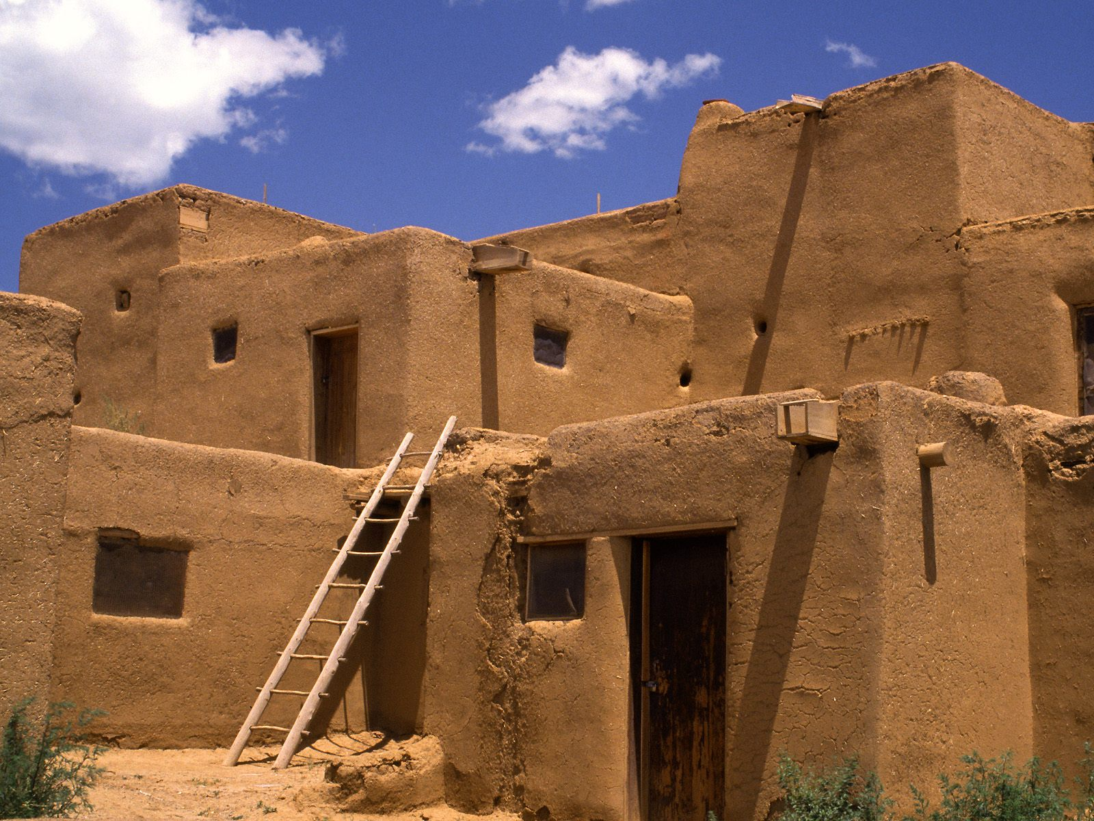 | In the American South, the Pueblo Indians built strong square houses out of clay bricks.
 | …and of course there is the typical tepee, as already seen before.
Traditional houses in Austria, on the other hand, look very different.
These houses did and still do not only accommodate people, but also animals.
There are special sections that are called “stables“, where chicken, pigs and even cows are kept.

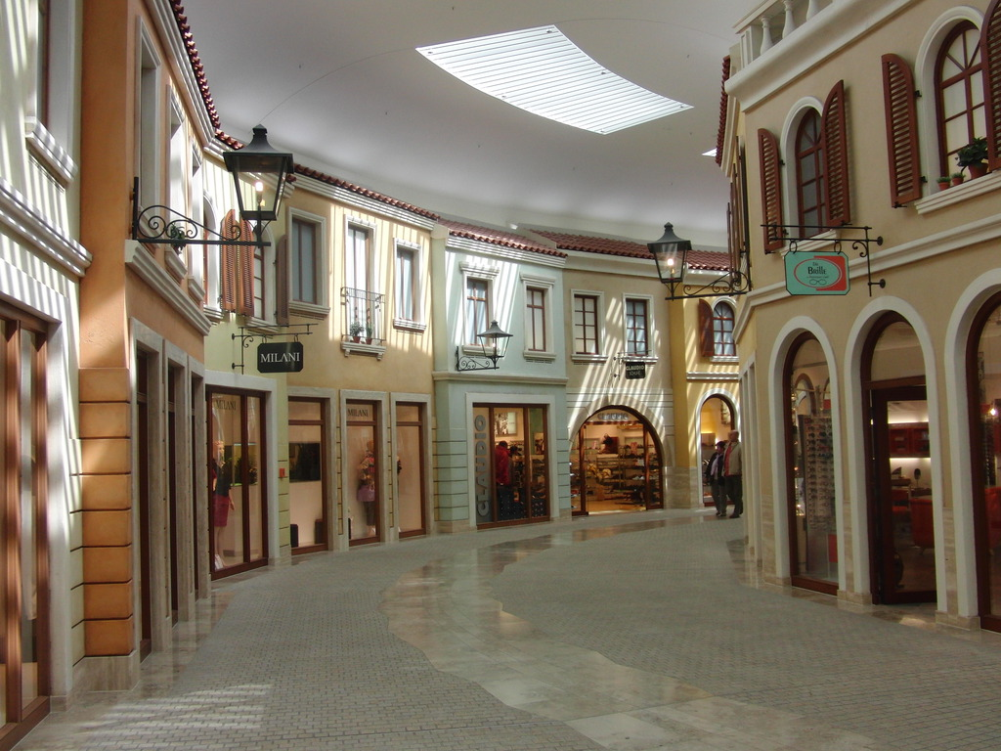 | Americans have not got a long history – they have not got any very old, historical buildings.  However, they like copying old, traditional buildings from Europe.  In the shopping mall you can see here, they have copied Italian housing styles.  They have also copied the Austrian style – for example in Leavenworth, Washington state. This city looks like a place in Austria or Switzerland.
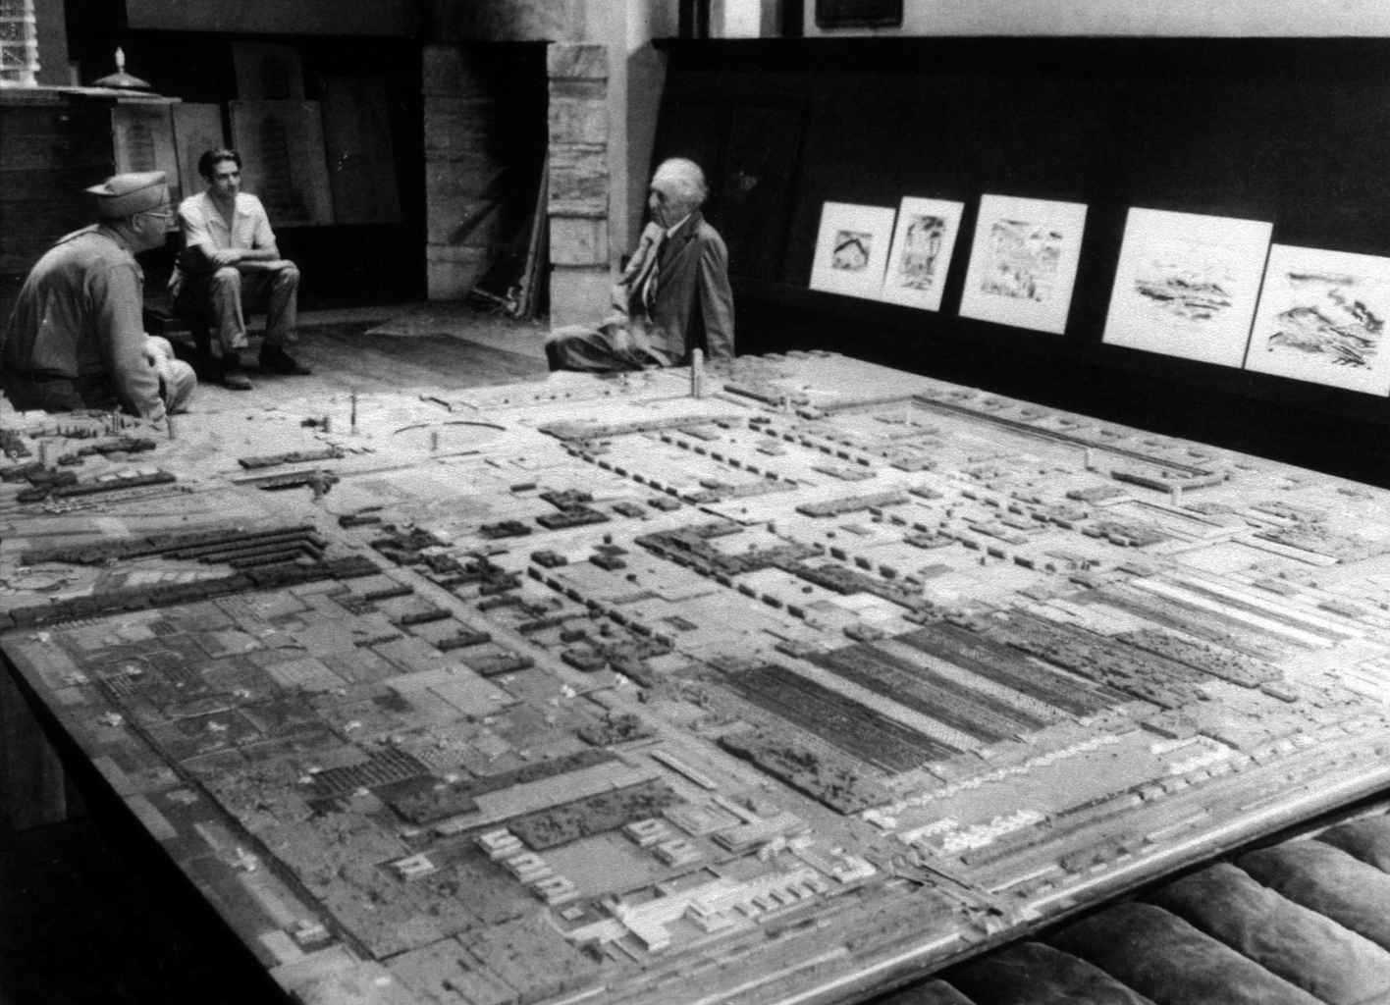 | Because of their young history, many cities have not grown naturally, but have been carefully planned on a drawing board.
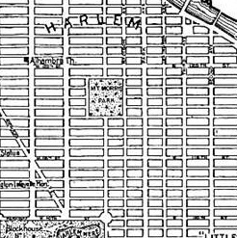 | As a result, the cities are very often based on a checkerboard pattern, which means that the streets and avenues follow a very regular pattern.

The importance of mobility, as well as access to cheap energy, enough space and the nation’s young history
have produced a TYPICAL STYLE IN AMERICAN HOUSING:
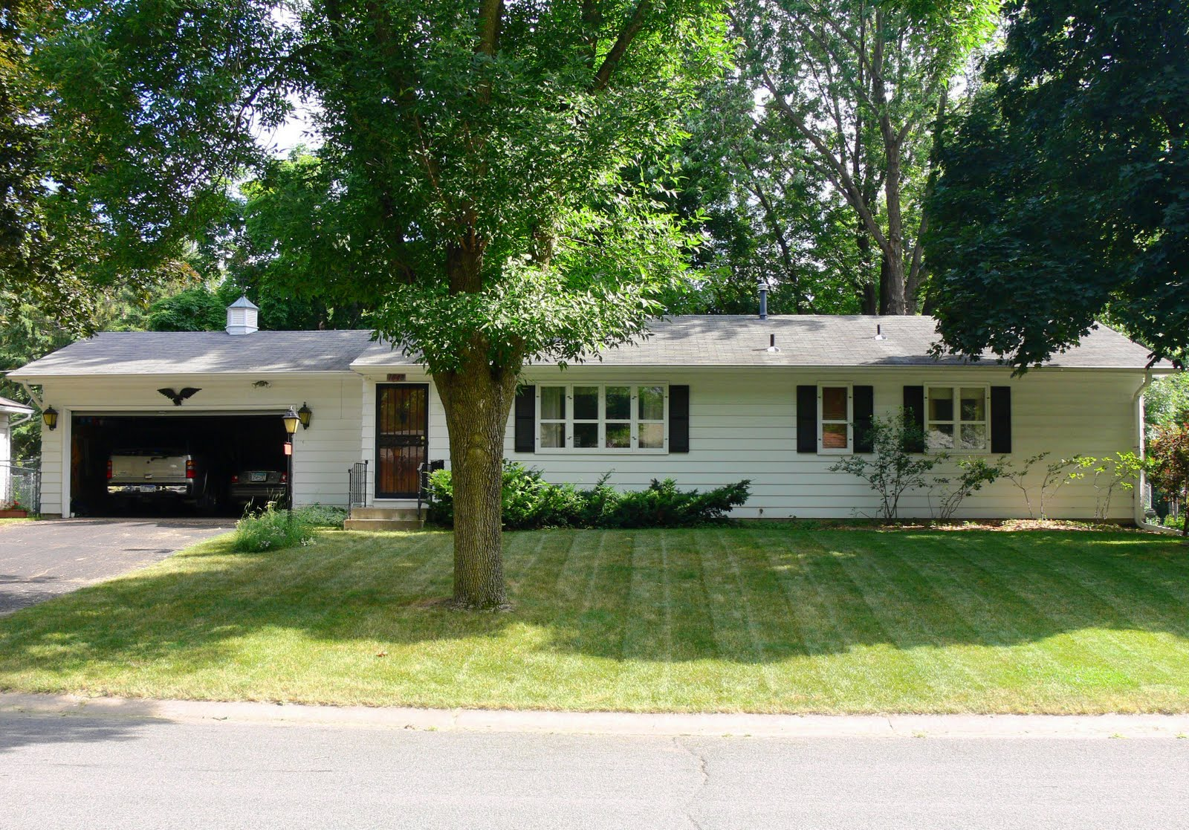 | The typical American single-family house consists of just one floor.  Some buildings have not even got a basement.  These houses are made out of wood and have very thin walls.  Many of them are prefabricated houses.
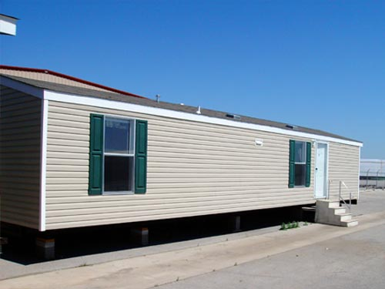 | This is a cheaper version of a prefabricated house.  This house does not have real shutters: They are just painted on.

MODERN architecture in Vorarlberg compared to the US
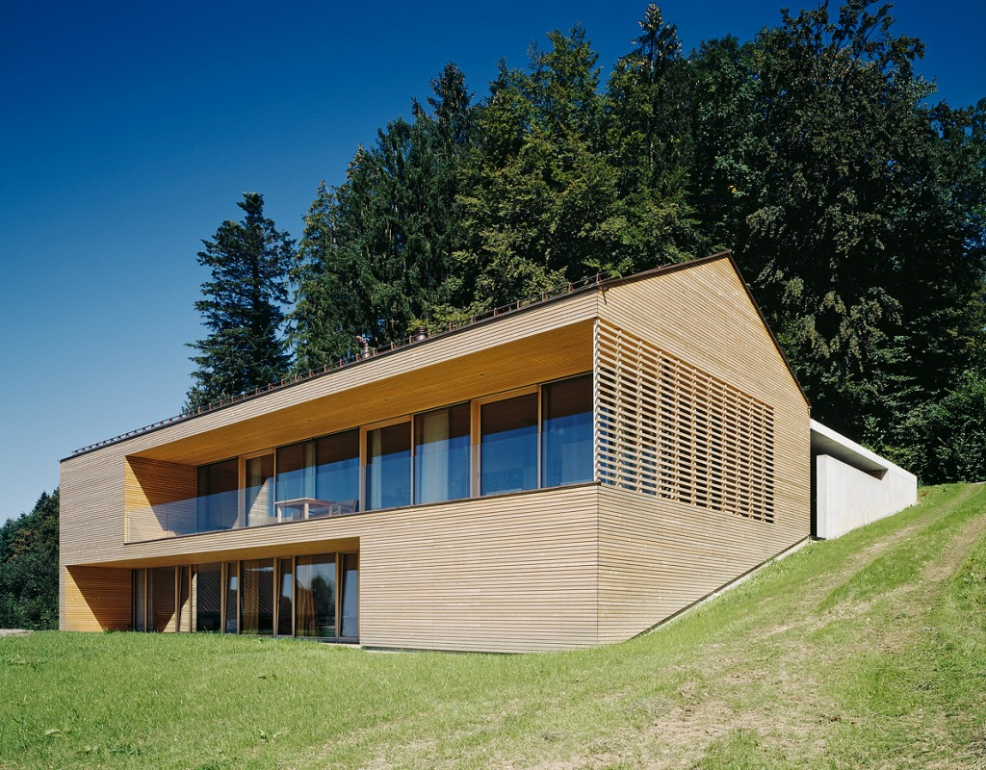 | Wooden houses have become increasingly popular in Vorarlberg in recent years.  Many of these wooden houses follow the so-called passive-house concept.  These houses use very little energy. They are very well insulated, are primarily heated by solar energy and have solar panels to produce warm water for everyday use as well as for the heating system.  With the passive house concept 90% of the heating costs can be saved.  It is interesting to note that as of August 2010, there were approximately 25,000 passive house structures of all types in Europe, while in the United States there were only 13.
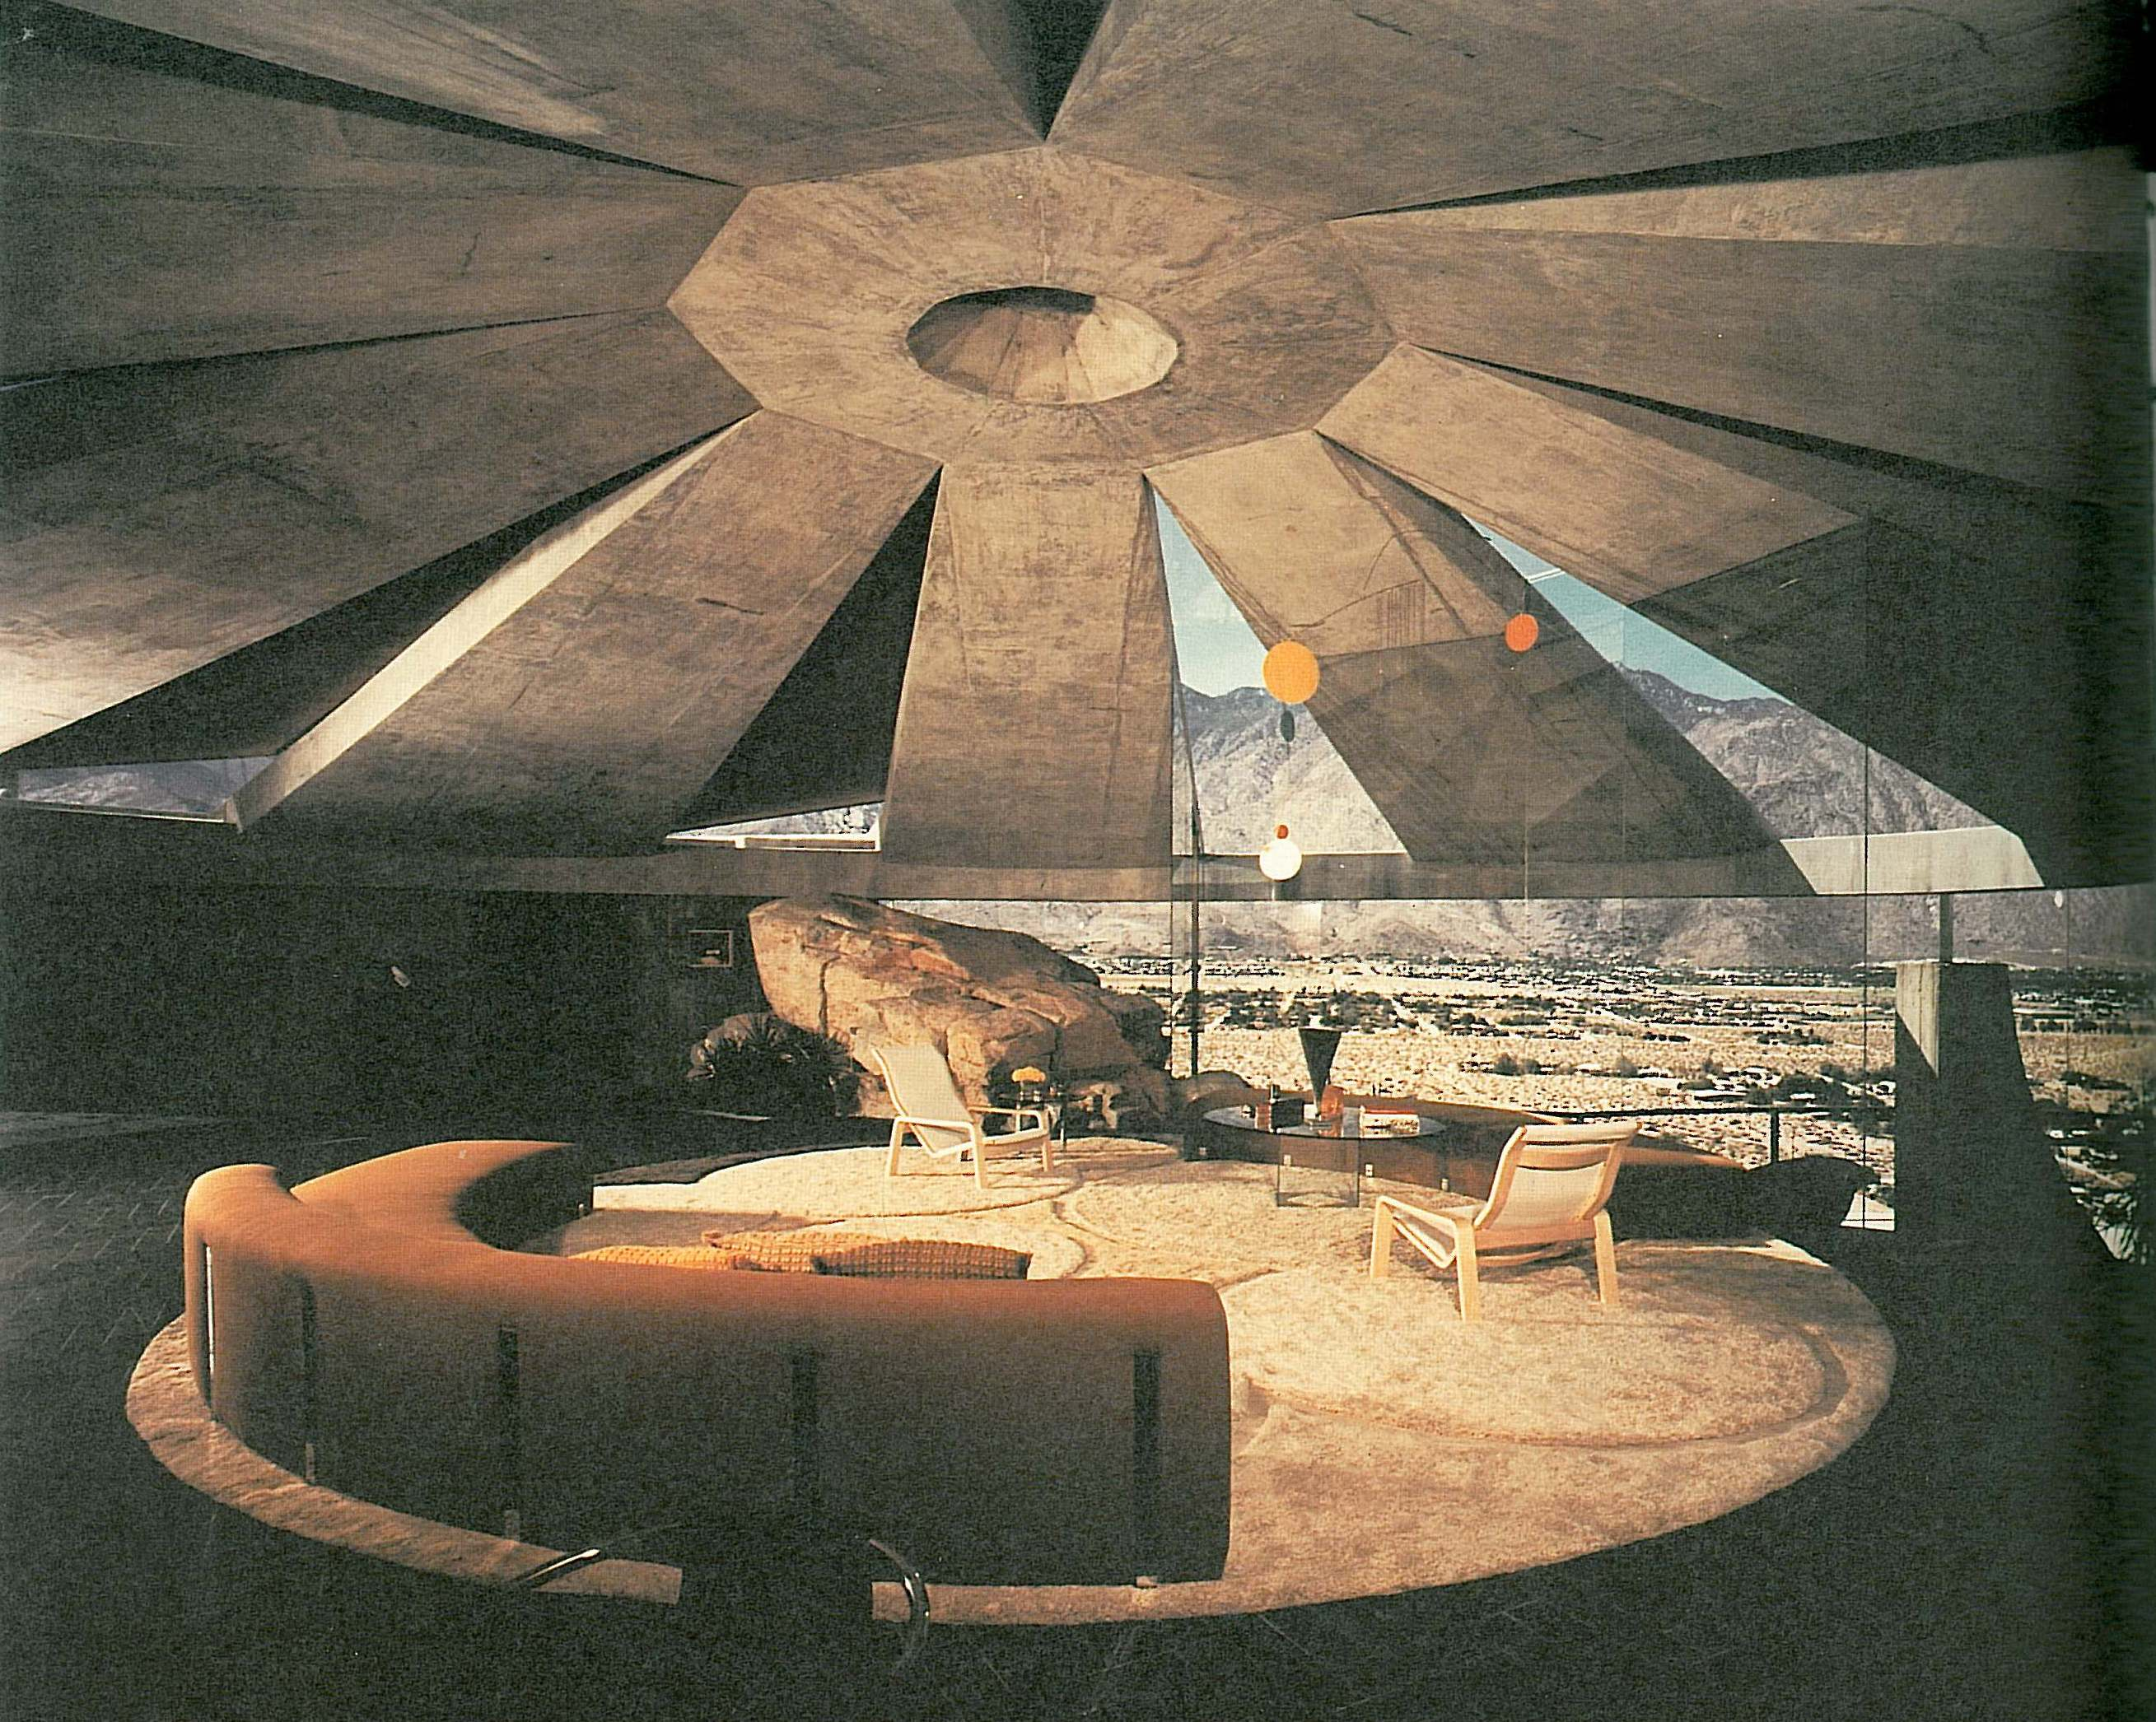 | On the subject of modern architecture in the US, there is no way to avoid mentioning John Lautner (1911-1994). John Lautner was of mixed Austrian and Irish descent.  His buildings have starred in James Bond movies like “Diamonds are Forever“ as well as “Charlie‘s Angels“.
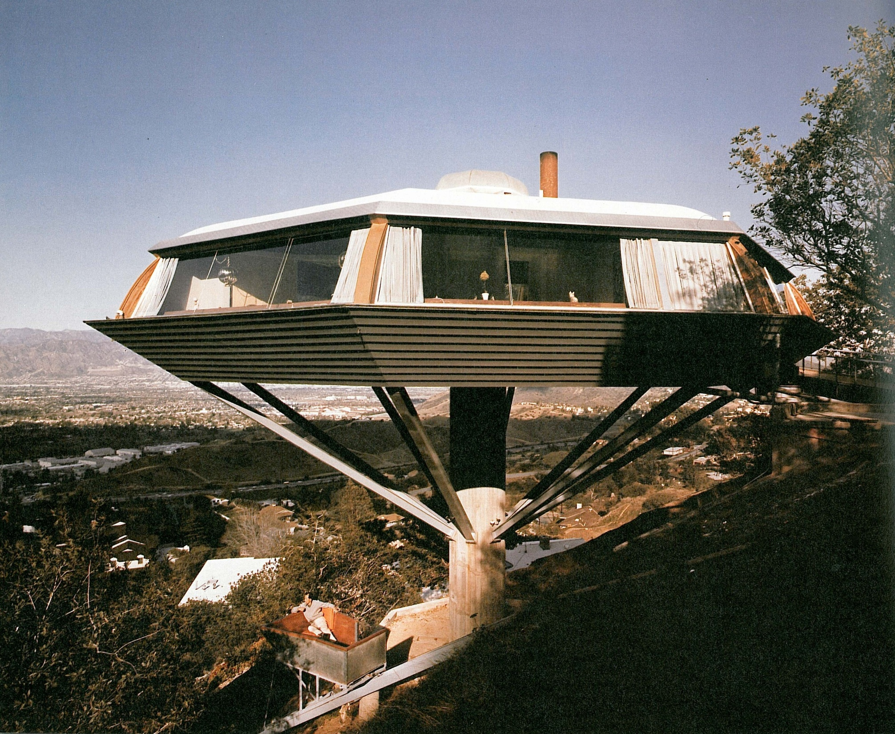 | The Chemosphere, as this house is called, is one of his best-known creations.  It is situated in West Hollywood.  The house is octagonal in plan and is often described as a flying saucer.

